**First-person Robotic Arm Control with Hand Motions in Virtual Reality**

**Oklahoma State University, Stillwater, OK**

**Abstract**

With the rapidly growing virtual reality (VR) technologies, maturing motion tracking applications, and the advancement in robotics, physically interacting with the remote world via a robot while the user is observing the scene through a VR headset seems to be one solution to the substantial need for telepresence. This workshop presents a first-person viewing hand motion controlled robotic arm framework that provides an immersive robot control experience. In particular, we developed a platform with an off-the-shelf 360° camera, a robotic arm, and a VR headset to allow for live 360° video streaming, hand tracking, and robotic arm control. Demo activities with three types of robot operation tasks (i.e., in-air drawing, object collection, and line tracing) will be discussed during this workshop.

**Contents**

This 2-Hour workshop will cover comprehensive VR technologies and Robotics Arms. Then the participants will experience controlling robot arms using VR equipment.

**Intended audience**

Any electrical/mechanical/mechatronics/robotics engineers, engineering managers, engineering students, teachers or faculty members who are willing to learn VR technologies and Robotics.

**Materials provided**: Lecture notes and workshop handouts will be provided.

**Venue**: Hamm Institute for American Energy, OKC, OK

**Schedule:** September 28, 2023

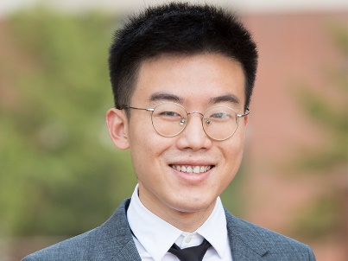**Instructors**

Dr. Wang is an Assistant Professor in the Electrical Engineering Technology department and an Adjunct Assistant Professor in the School of Electrical and Computer Engineering at OSU. He received the B.Eng. degree in information engineering from Southeast University, Nanjing, China, in 2012, and the Ph.D. degree in electrical engineering from the Stevens Institute of Technology, Hoboken, NJ, USA, in 2018. From 2016 to 2017, he was a research intern with the Mathematics of Networks and Systems Research Department in Nokia Bell Labs, Murray Hill, NJ, USA. He joined Futurewei Technologies Inc., Bridgewater, NJ, USA, in 2018. His research interests include deep learning, wireless communications, deep reinforcement learning, and robotics. He was a recipient of the outstanding Ph.D. Dissertation Award in electrical engineering and the Edward Peskin Award with the Stevens Institute of Technology, in 2018.