**Bernoulli, can you give me a lift?**

**Background:**

**In the 1700’s, a Swiss mathematician and physicist named Daniel Bernoulli noticed when water (or gas) flowed over an object, it’s speed and pressure changed. Bernoulli’s Principle states that when water (or air) flows around an object, the water (or air) pressure changes as the speed of the water (or air) changes. When water (or air) moves faster over an object, it lowers the pressure. When the water (or air) moves slower over an object, it raises the pressure. “The faster the water (or air) moves, the less pressure it exerts.”**

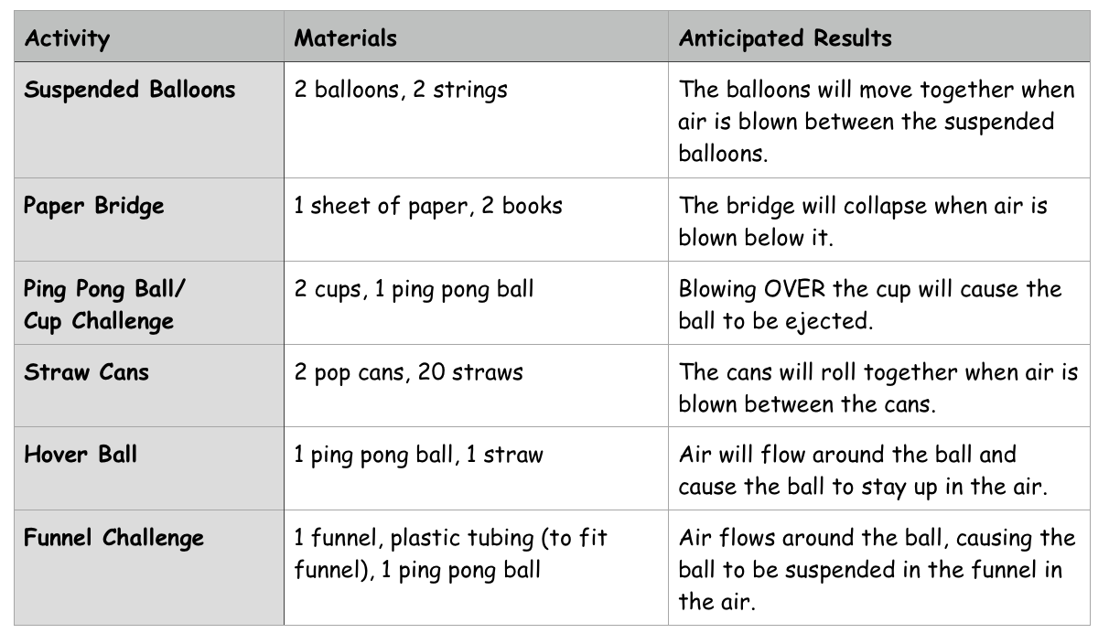

**Suspended Balloons**

**Activity #1**

**Materials:** 2 balloons, 2 pieces of string (approx. 30 cm)

**Predict:** What do you think will happen when you blow air between the balloons?

**Instructions:**

1. Inflate the balloons and attach one string to each balloon.
2. Hold one string in each hand with the balloons face level and about 3 – 4 cm apart.
3. Blow between the balloons.

**Questions:**

1. What observations did you make?
2. What were your conclusions?

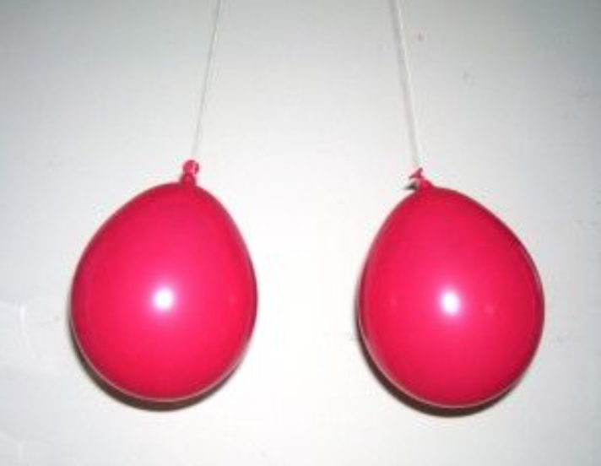

**Paper Bridge**

**Activity #2**

**Materials:** 2 thick books, 1 piece of paper

**Predict:** What do you think will happen when you blow underneath the paper and between the two books?

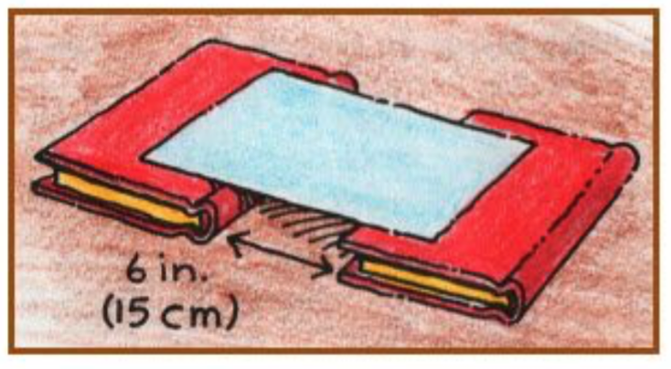

**Instructions:**

1. Place the books about 15 cm apart.
2. Place the paper on top of the books.
3. Blow air underneath the paper and between the two books.

**Questions:**

1. What observations did you make?
2. What were your conclusions?

**Ping Pong Ball/ Cup**

**Activity #3**

**Materials:** 1 ping pong ball, 2 clear cups

**Predict:** How can you move the ball from one cup to the other without touching the cup and the ball?

**Instructions:**

1. Place the ping pong ball in one of the cups.
2. Place the other cup vertical to the first cup and about 15 cm from the first cup (can move if needed).
3. Try various methods to get the ball from the first cup to the second. Record which methods work and which methods do not work.

**Questions:**

1. What observations did you make?
2. What were your conclusions?

**Straw Cans**

**Activity #4**

**Materials:** 2 empty pop cans, approximately 24 straws

**Predict:** First, read the instructions. What do you predict will happen?

**Instructions:**

1. Place 20 straws parallel to one another (approximately 1 cm apart).
2. Place the cans about 5 cm apart.
3. Using a straw, blow between the cans.

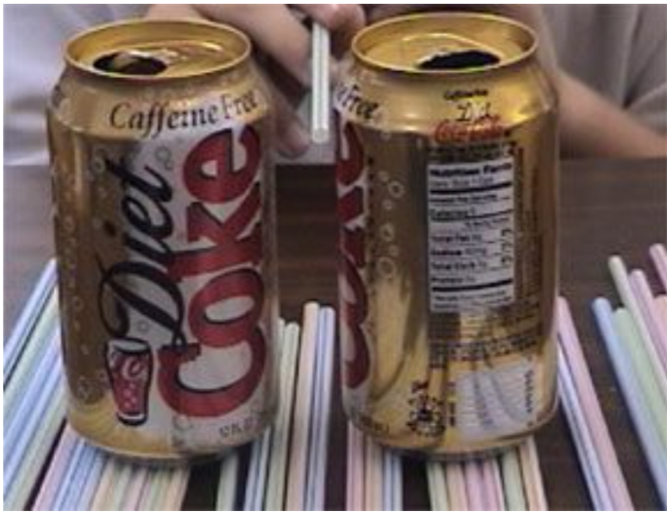

**Questions:**

1. What were your observations?
2. What were your conclusions?

**Hover Ball**

**Activity #5**

**Materials:** flexible straw, ping pong ball

**Predict:** What will happen when you blow air through the straw with the ball at the bended opening?

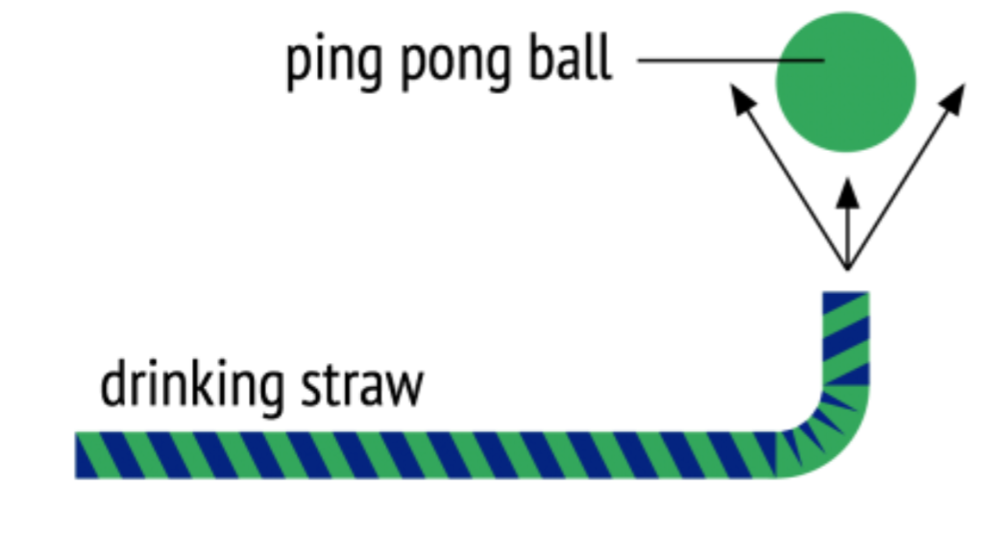

**Instructions:**

1. Bend the straw so that the short end is pointing up.
2. Hold the ball over the opening and blow.
3. Let go of the ball.

**Observations:**

1. Observe what happens when you let go of the ball.
2. What are your conclusions as to why this occurs?

**Funnel Challenge**

**Activity #6**

**Materials:** funnel (or cone), ping pong ball

**Predict:** What will happen to the ball when you blow through the bottom of the funnel?

**Instructions:**

1. Place the ball in the small opening of the funnel.
2. Blow air through the opening in the bottom of the funnel.

**Questions:**

1. What observations did you make?
2. What were your conclusions?

