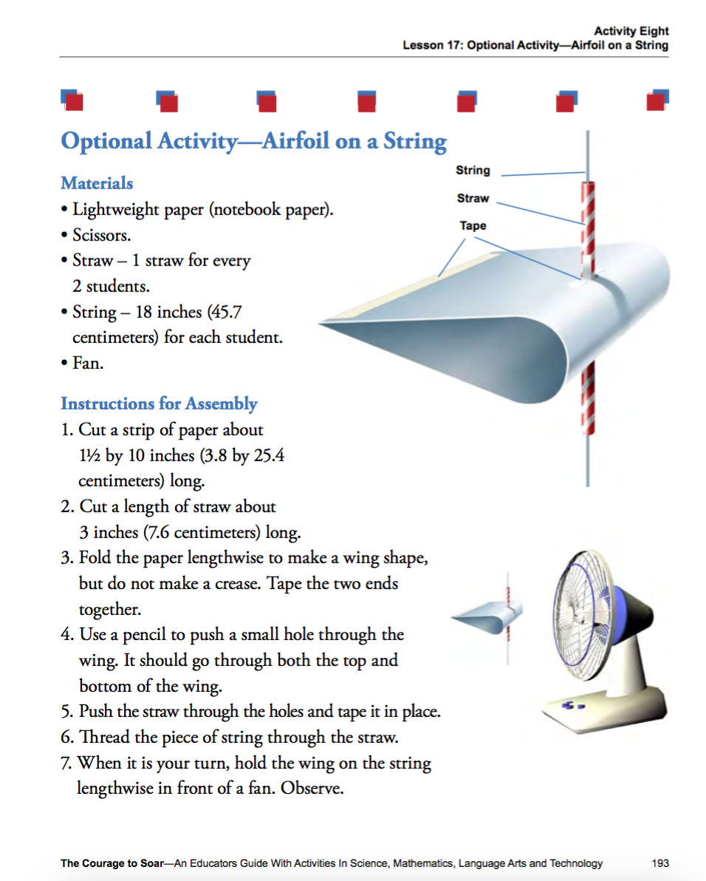

**Extension Activity:**

1. Provide each group with a box of paper clips.
2. Using the paper clips, have the students experiment to see how much weight (or paper clips) it will take to eliminate the wings ability to lift in the air.
3. Once all of the students have been successful, compare and contrast where they placed the paper clips and how many paper clips it took to zero out the lift with increased weight.