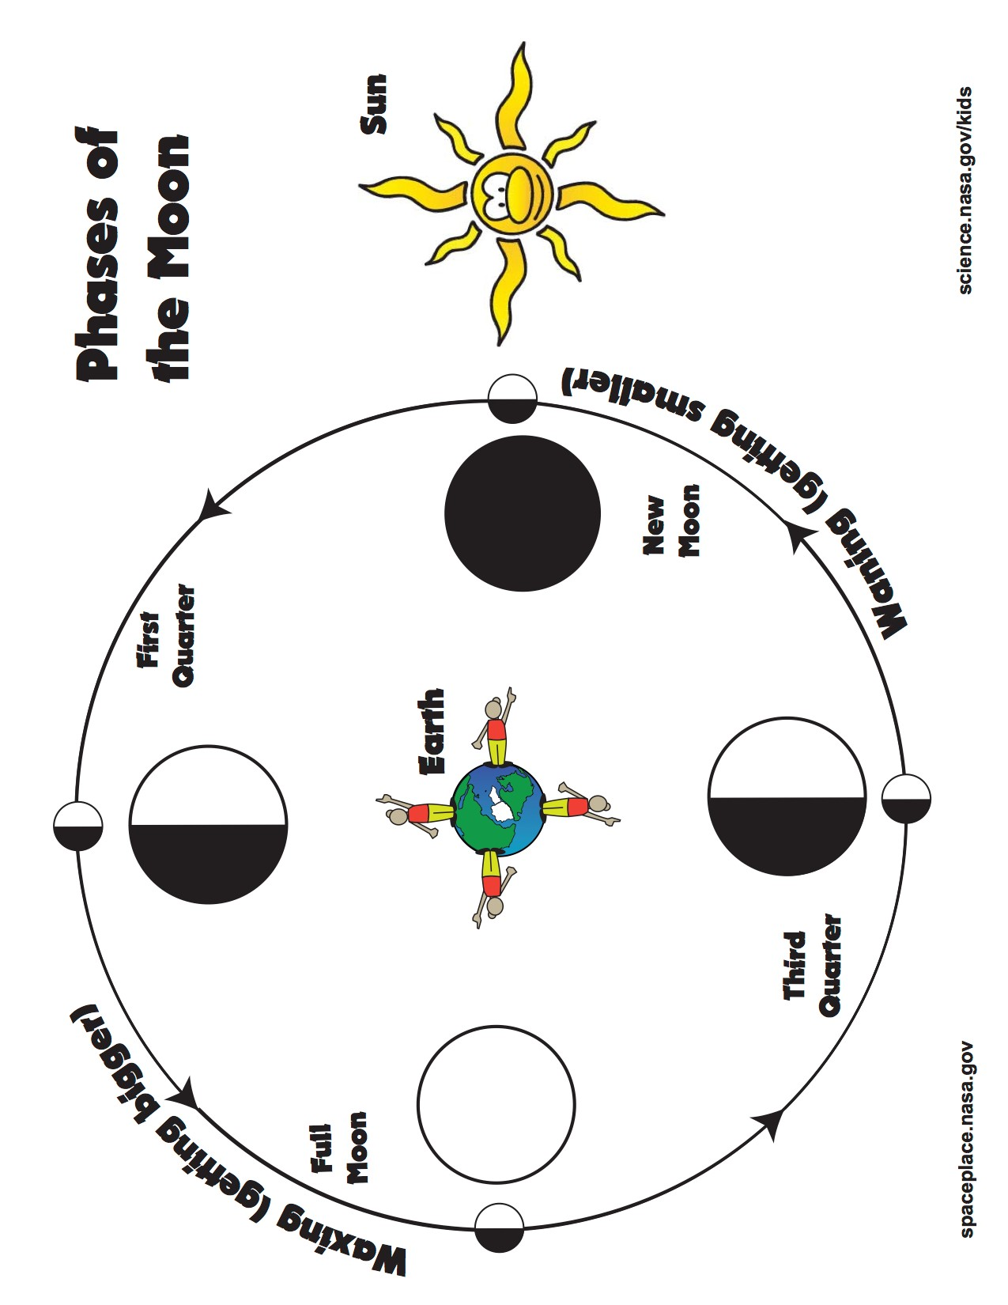

The students will then use the following placemat as a guide to practice creating Oreo Moon Phases. After they have created the phases using the placemat, the students will then glue the phases onto the paper plate and label the phases. The students will be able to eat the remaining cookies.

(another version of placemat)