**STRAW ROCKETS**

1. Please take the strip of register tape out of your baggie (leave the straw in the baggie for now).
2. Using a ***pencil*** and the strip of register tape, roll the strip of register tape around the pencil and tape the end to the paper (Do not tape the paper to the pencil, only to itself. As you wrap it, be sure not to wrap it too tight nor too loose.).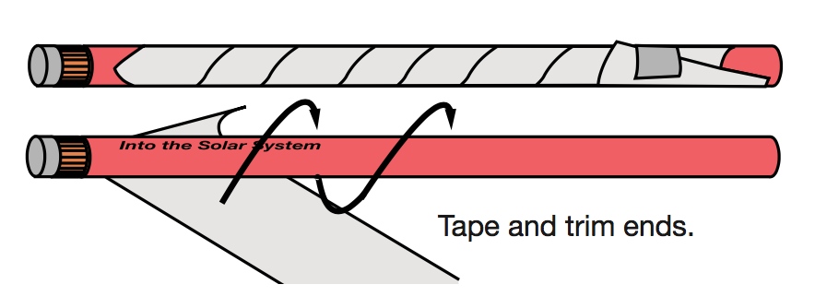
3. Gently pull the pencil out and set to the side.
4. Carefully push down one end of the tube and tape.
5. Take the straw out of the baggie. Take the straw and tube to the designated launch station.
6. Insert the straw into the hole on the tube and blow! While at the launch station, try the following:

a. Hold your head straight and launch your rocket. What happened? Where did your rocket travel? How far did your rocket travel?

b. Holding your mouth facing the ceiling, blow your straw rocket. What happened? Where did your rocket travel? How far did your rocket travel?

c. Looking straight ahead, slightly angle your mouth and blow the straw rocket. What happened? Where did your rocket travel? How far did your rocket travel?

***What did we learn?***

Trajectory- the path a moving object takes when force is applied.

The trajectory (or angle), I set for my rocket will decide how far and in which direction my rocket will go. When getting a space vehicle to re-enter Earth’s atmosphere, NASA must precisely map out the trajectory to ensure the space vehicle enters at the right angle in order to land in the proper location.