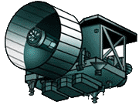**Mapping a Mystery Landscape**

**Background:**

One of the instruments on board probes (satellites) that visit planets and moons in our Solar System is a laser altimeter. This instrument sends pulses of light down to the surface and measures the time it takes the light to be reflected back to the spacecraft. In this manner, the topography or altitude of features on that surface can be measured. In this activity, you will simulate this process of using a laser altimeter to map the surface of a mystery landscape.

**Materials:**

* Mystery landscape box
* “Laser Altimeter” dowel (measuring stick)
* Graph paper
* Construction paper

**Procedure:**

1. Using your dowel, determine how far it is to the surface by gently pushing it through each hole and recording the distance in the **Data Collection chart** on the back of this sheet. Each row of holes represents one orbital path of the satellite. Your satellite will make 6 passes (A-F). Be sure to keep your dowel perfectly straight.

2. Fold a piece of graph paper in half the long way. The fold represents the cover of your box.

3. Horizontally, number 1-12 along the fold with 3 lines between each number (begin at the very edge of the left side of the fold). There will be only 2 lines between numbers 11 and 12. Vertically, number each line 1-16.

4. On the “A” side, plot the data you collected for orbital pass “A”. For example:

|  |  |  |  |  |  |  |  |  |  |  |  |  |
| --- | --- | --- | --- | --- | --- | --- | --- | --- | --- | --- | --- | --- |
|  | **1** | **2** | **3** | **4** | **5** | **6** | **7** | **8** | **9** | **10** | **11** | **12** |
| **A** | **8** | **8.5** | **9** | **10** | **10** | **9** | **7** | **6** | **4** | **4** | **3** | **3** |

5. Connect the data points with a smooth line.

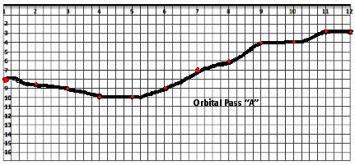6. Label the side of the graph paper “A”.

**Fold – Represents the top of the box**

7. Use the other side of the graph paper and plot the data for orbital pass “B”. Label “B”.

8. Plot and label the remaining the C, D, E and F orbital passes.

9. When all 6 landscapes are finished, cut them out and trace them onto construction paper **adding 1 extra inch to the bottom of each landscape** (see the diagram below). This extra inch will be folded over so your landscape profile can stand up. In most cases you can fit 3-orbital passes on a large sheet of construction paper.

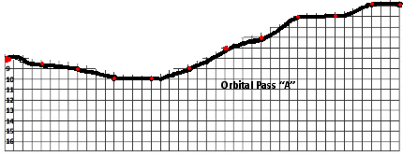

**Construction Paper**

**1 inch**

10. Glue your 6 landscape profiles onto a piece of white construction paper. Make sure the profiles are in the correct order with “A” in the back and “F” in the front. The 1-inch tabs should be glued **in front** of the landscape profile. **Write your names and box # on the back of your landscape profile.**



**A**

**B**

**C**

**D**

**E**

**F**

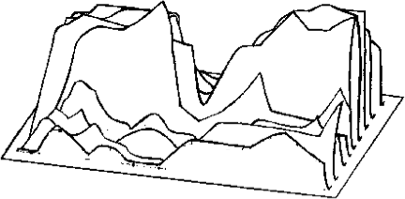

**Data Collection**

|  |  |  |  |  |  |  |  |  |  |  |  |  |  |
| --- | --- | --- | --- | --- | --- | --- | --- | --- | --- | --- | --- | --- | --- |
| **Orbital**  **Pass** | **Elevation Measurement** | | | | | | | | | | | | |
| **1** | **2** | **3** | **4** | **5** | **6** | **7** | **8** | **9** | **10** | **11** | **12** |
| **A** |  |  |  |  |  |  |  |  |  |  |  |  |
| **B** |  |  |  |  |  |  |  |  |  |  |  |  |
| **C** |  |  |  |  |  |  |  |  |  |  |  |  |
| **D** |  |  |  |  |  |  |  |  |  |  |  |  |
| **E** |  |  |  |  |  |  |  |  |  |  |  |  |
| **F** |  |  |  |  |  |  |  |  |  |  |  |  |