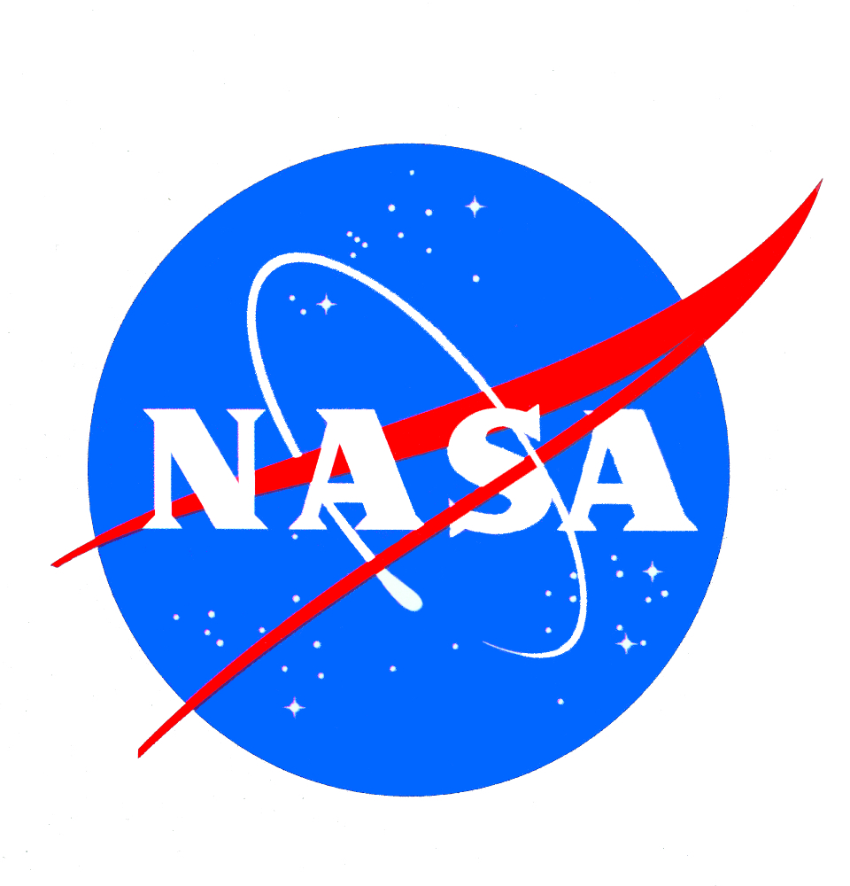

**Dorinda Risenhoover, Education Coordinator**

**NASA Oklahoma Space Grant Consortium/ NASA EPSCoR**

**NASA OSGC Educator Resource Center**

[dorinda.risenhoover@okstate.edu](mailto:dorinda.risenhoover@okstate.edu) 405-314-9161

[nasaosgcerc.okstate.edu](http://nasaosgcerc.okstate.edu) Twitter: @DorOKSG

**Brittany Board, MTPE Class of 2012 Ambassador**

Lower Elementary Teacher, Lakewood Montessori School

[Bboard@lmschool.org](mailto:Bboard@lmschool.org) (817) 975-9036

**Kimberly Morgan, MTPE Class of 2016 Ambassador**

Pre-service Educator, Cameron University (Oklahoma)

[kimberly.morgan@cameron.edu](mailto:kimberly.morgan@cameron.edu) 918-803-1765

In the last few decades, we have seen a huge shift in education as a whole, going from explorers and thinkers to receivers of lots of facts and information in order to do well on the test. In many classrooms, learning through seeing and understanding has been replaced by work and worksheets. While done with the best of intentions in hopes to cram as much information in a finite amount of time, often this leads to a lack of retention of the ideas and themes. This is where the learning cycle comes into play!

The Learning Cycle is a 3-part scientific process by which students are initially immersed in “play” (*Exploration*). Then, they use their words of the “play” to create the concept (*Concept Invention*). Finally, they expand on their knowledge of the concept through more “play”, video, display of information, etc. (*Expansion*).

“Blasting Off with Newton’s Laws Through the Learning Cycle!” is a small portion of the hands-on STEM-based activities taught to pre-service educators who attend the NASA Oklahoma Space Grant Consortium’s Summer Teacher Institute: Mission To Planet Earth (2017 will mark its 22nd year). These 3 rocketry learning cycles were developed by Dorinda Risenhoover, Education Coordinator for the NASA OSGC, and have been fine-tuned over the last 20+ years with thousands of groups of students and educators. Brittany Board (MTPE Class of 2012) and Kimberly Morgan (MTPE Class of 2016), co-presenters and NASA OSGC MTPE Ambassadors, were immersed in these activities while attending MTPE and have taught all or portions of the lessons to students in both the public and private sector.

Activities include playing with Newton’s bags (a set of “toys” designed to illustrate Newton’s first law of motion through play), creating fizz rockets, constructing Hero-s engines, dropping an egg in a payload protection device, and designing/ engineering a 2-liter bottle rocket. All of the activities use either inexpensive or recycled materials. The participants will learn just like they would teach it in the classroom! The emphasis is on the Exploration and Expansion with the participants taking charge of their learning. Through experiencing Newton’s Laws in this manner, the participants gain a new love for teaching Newton’s Laws through the Learning Cycle which, in turn, helps them write the information on their student’s brains through “play”.

I. Introduction (5 minutes)

A. Our Backgrounds

B. What is the NASA Oklahoma Space Grant Consortium?

C. What is “The Learning Cycle”?

II. Newton’s First Law of Motion (25 minutes)

A. Exploration (Play)- Newton Bags (5 minutes)

B. Concept Invention (10 minutes)

C. Expansion- Fizz Rockets (10 Minutes)

III. Newton’s Third Law of Motion (25 minutes)

A. Exploration (Play)- Hero’s Engines (5 minutes)

B. Concept Invention (10 minutes)

C. Expansion- Hero’s Engines Competition (10 minutes)

IV. Newton’s Second Law of Motion (30 Minutes)

A. Exploration (Play)- Eggbert (10 Minutes)

B. Concept Invention (5 Minutes)

C. Expansion- 2-Liter Bottle Rockets (15 Minutes)

V. Wrap-up (5 Minutes)