2023-2027
College of Engineering, Architecture and Technology

Strategic Plan: Draft 3.0
Zink Center for Competitive Innovation

Contents

INTRODUCTION

VISION

MISSION

GOALS 2027
- Collegiate Competition Goal

- Innovation Goal

- STEM Outreach Competition Goal

INTRODUCTION
The Zink Center for Competitive Innovation and Leadership was founded in 2022 with a gift from The Zink Family Foundation. The Center perpetuates the spirit of John “Jack” Zink, whose legendary ingenuity, grit, and competitive drive carried his team to the Indianapolis 500 Victory Circle and beyond.
We envision graduates of Zink Center programs prepared to lead intellec-tually, technically, and ethi-cally. We envision graduates who are ready and willing to tackle the ‘impossible’, who have the technical, interper-sonal and leadership skills necessary to propose inno-vative solutions to challeng-ing problems—and the grit, perseverance, and creativity to get the job done!
VISION
The Zink Center will transform Oklahoma State University students into ethical, next generation leaders, whose grit, innovation, and competitive spirit will make the world a better place for all.

We will engage with a broad spectrum of current and future OSU students to create, promote and develop state, regional and national collegiate and STEM competition teams in all areas of interest to CEAT students.

MISSION
The mission of the Zink Center is to create, promote and develop interdisciplinary innovation teams for the benefit of current and future generations of OSU students.

Many engineering societies are well-known for their international collegiate competitions. Competitions bring together students from across the country or the region to compete for top honors in a variety of categories. The Zink Center will leverage the recent successes of our teams to develop and maintain vibrant, nationally-recognized, student-run competition teams. We will provide design-build spaces for our teams and mentor team leaders in communication, project management and teamwork skills.
Collegiate Competition Goal: Achieve national recognition for our highly professional, student-led, interdisciplinary competition teams.
Strategic Priorities for Competition Teams Goal
- Incubate and develop new CEAT competition teams within the existing Interdisciplinary Senior Design framework
- Develop Student leaders by:
  - Sponsoring leadership seminars
  - Providing hands-on training in manufacturing, design, planning, and problem-solving skills
  - Mentoring team leaders in one-on-one and group settings
- Develop and maintain well-equipped, well-organized, safe, and collaborative, student-run makerspaces and design environments
- Sponsor team travel to national competitions
- Create Excellence in Leadership fellowships
- Create bylaws that:
  - Articulate the leadership and funding model governing the Zink Center
  - Articulate the qualifications, responsibilities, and benefits associated with membership on the:
    - Zink Center Advisory Council
    - Zink Center College of Mentors
    - Zink Center Student Leadership Council
Metrics for Competition Teams Goal
- 4 keynote lectures from industry leaders each semester
- 10 online training modules in critical leadership and management topics
- 6 ‘hands-on’ training modules in industry-critical fabrication and manufacturing processes offered once each semester
- 3 faculty and/or industry mentors engaged with each Zink Center competition team
- State-of-the art, student-run makerspaces supporting 5 Zink Center Competition teams
- $100,000 in annual team competition travel and Excellence in Leadership fellowships

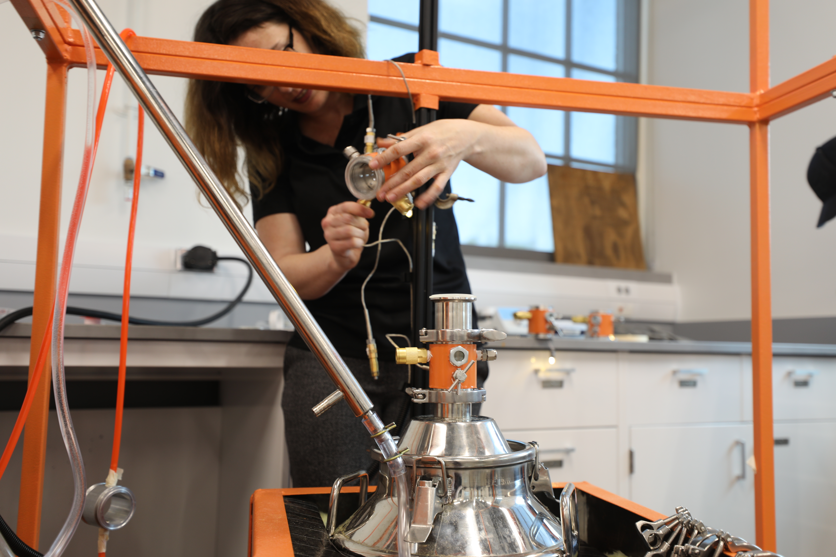
The Zink Center will leverage the exceptional makerspaces, teaching laboratories and shop facilities available to CEAT students to create a culture of innovation within the CEAT academic programs. The Zink Center will partner with the CEAT academic units, the Riata Center for Innovation and Entrepreneurship and the School of Entrepreneurship to create opportunities for interdisciplinary student teams to develop and nurture a spirit of innovation and entrepreneurship.
Innovation Goal: Create a culture of innovation within the CEAT programs
Strategic Priorities for Innovation Goal
- In collaboration with the School of Entrepreneurship, design an ‘Innovation Option’ suitable for adoption by the CEAT academic programs.
- Create a freshman/sophomore design-build competition to anchor the CEAT freshman experience and provide opportunities for CEAT students to develop teamwork, innovation and rapid prototyping skills
- Create a section of Introduction to Engineering focused on innovation and entrepreneurship. The course will feature:
  - Guest speakers from the Riata Center and School of Entrepreneurship
  - Mentoring and Instruction in teamwork and communication
  - Development of hands-on rapid prototyping skills
  - Participation in a freshman/sophomore design-build competition
- In collaboration with the Riata Center, create opportunities for interdisciplinary teams of entrepreneurially-minded students to persist through graduation by:
  - Creating suitable technical electives
  - Accommodating interdisciplinary senior design teams focused on launching a business around a new product design
Metrics for Goal
- Adoption of the entrepreneurship option in 3 CEAT programs
- 100 students participating in the freshmen/sophomore design competition each semester
- 100 freshmen participating in the innovation section of Introduction to Engineering each academic year
- 5 interdisciplinary senior design teams focused on prototyping a new product and launching a new business each academic year
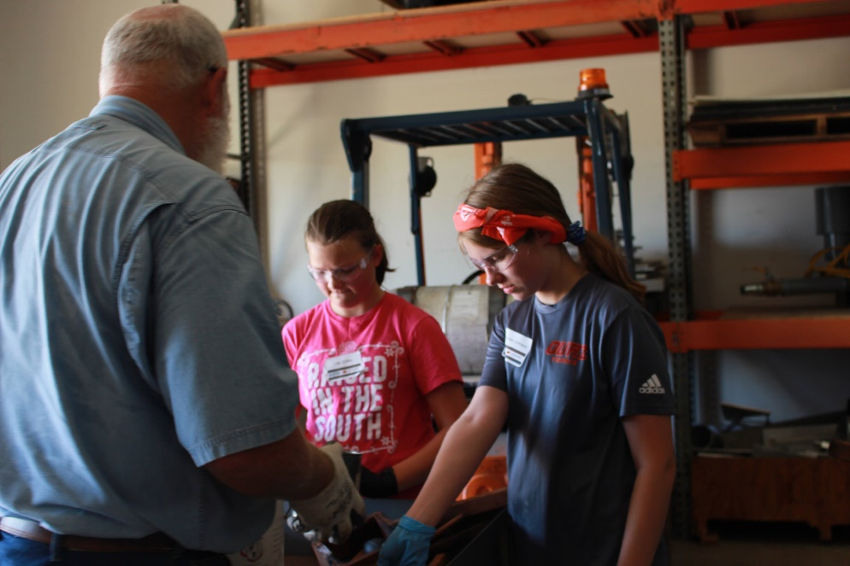
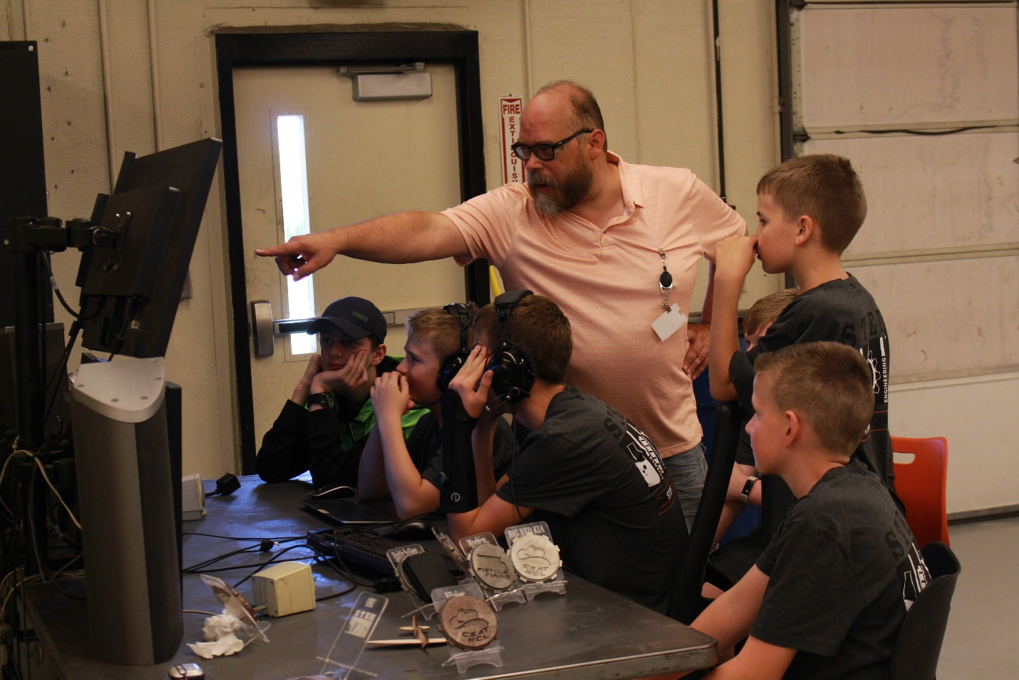
The Zink Center is uniquely positioned to support CEAT, state and national competitions designed to inspire Oklahoma middle and high school students to pursue careers in science, technology, engineering, or mathematics. Zink Center technical staff will collaboratively support hands-on STEM competitions in our makerspaces by providing instruction in manufacturing process and instruction in design, teamwork and leadership and project management.
STEM Outreach Competition Goal: Support existing STEM competition initiatives with mentors, instructors, and facilities.

Strategic Priorities for STEM Outreach Competition Goal
- Support established state, regional and national STEM competitions by providing participating student teams access to Zink Center makerspaces
- Participate in planning, facilitating, and leading STEM competition events on the OSU campus
- Encourage, train, and incentivize CEAT student leaders to participate in CEAT STEM outreach activities
- Increase the use of social media platforms to broadly communicate Zink Center success stories and activities at the student and organization levels

Metrics for Interdisciplinary Design Teams Goal
- Support 5 STEM outreach competition team activities each year
- Annually support 2 national and regional STEM programs in our makerspaces
- 5 student leaders actively collaborating with CEAT outreach programs and activities

